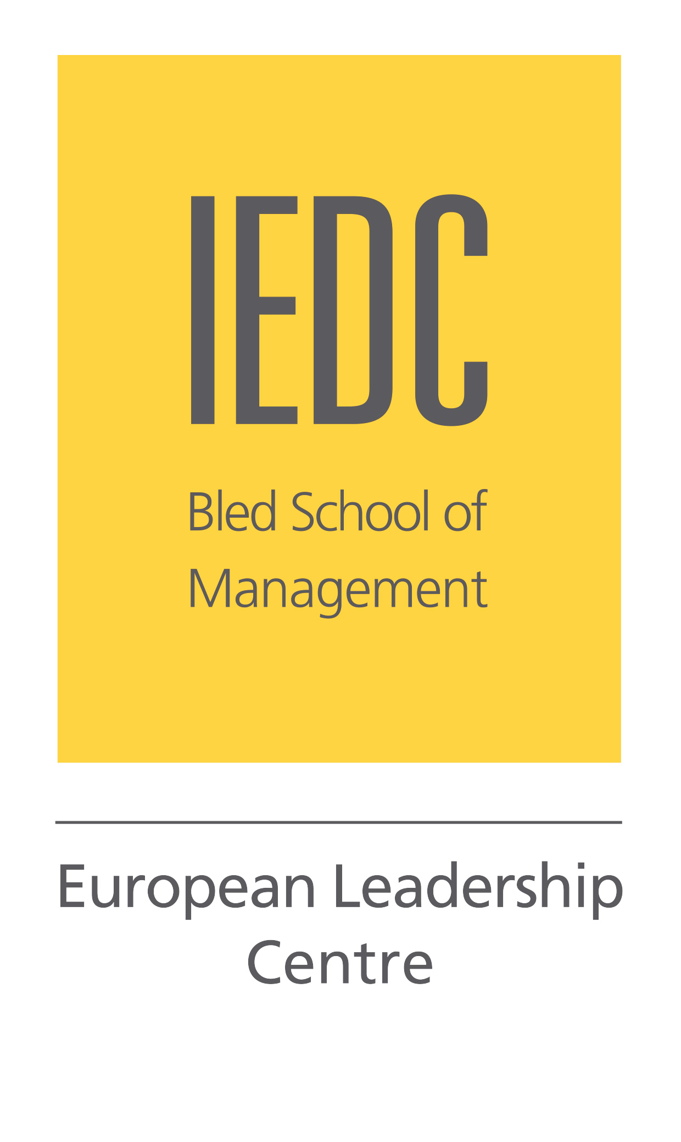
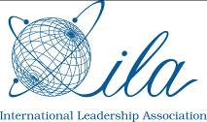
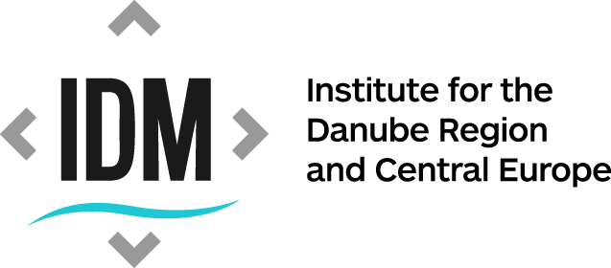
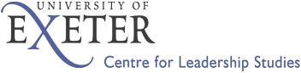
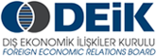

The EU and Turkey; Business and Political Leadership for a Common Future
June 7 - 8, 2012
IEDC-Bled School of Management, Slovenia

The modern Turkey ranks among the top 20 economies of the world. According to some prognosis it is estimated that by 2023, when Turkey celebrates its centennial, its economy will have moved to the position of top 10. Furthermore, the current Turkish administration is working towards EU membership and towards bringing about positive change in the Middle East and the Balkans.

Conference Chair: Prof. Pierre Casse, Leadership Chair at IEDC-Bled School of Management and Professor at Moscow School of Management

Thursday, June 7, 2012
14:30-15:00 Registraton
15:00 Welcome and Opening
Prof. Danica Purg, President, IEDC-Bled School of Management, Slovenia
Conference Chairman
15:20-15:45 The European Union and Turkey; A Leadership Challenge
Mr. Selim Yenel, Ambassador and Permanent Delegate of Turkey to the European Union
15:45–16:00 Q & A session
16:00-16:45 Europe and Turkey: Historical Links, Actual Relationships and the Future
Prof. Joshua Walker, a Transatlantic fellow at the German Marshall Fund, Washington, D.C.
Mr. Can Buharali, Vice Chairman, EDAM (Center for Public Policies Studies)
16:45-17:00 Q & A session
17:00-17:30 Break
17:30-19:00 Panel: Current Political and Investment Climate:
Panel moderator: Mr. Boštjan Skalar, Consul for Economic Affairs, Consulate General of the Republic of Slovenia in Istanbul
Mr. Ante Milevoj, Area Director, Centre of Competitiveness, Chamber of Commerce of Slovenia
Prof. Dragan Đuričin, President, Deloitte, Serbia
Dr. Murat Yulek, Dean, Faculty of Business Administration, THK University and Chairman of Turkish Investment Bank, Turkey
19:00 Closing comments of the first day
20:00 Evening reception

Friday, June 8, 2012

Conference Chair introduction:

09:00–10:30 Panel 1: The Role of Multinationals in Developing EU – Turkey Business
Relationships
Panel moderator: Daniel Pantić, Managing Director, European Consulting Group
Mr. Amer Bukvić, CEO, Bosna Bank International BiH
Mr. Gökhan Kamil Bozkurt, CEO, Turk Telecom
Mr. Boštjan Vodeb, General Manager Gorenje Turkey,
Mr. Ali Pandir, Chief Representative of Fiat/Chrysler

10:30–11:00 Break

11:00–11:45 The Role of Small and Medium Sized Businesses in Developing EU –
Turkey Business Relationship; Presentations of Hidden Champions Presidents from Slovenia and Turkey

11:45-12:30 Discussion in groups about the topics of the first two sessions (one big idea, one action, one question)

12:30-14:00 Panel 2: Leadership Challenge: A Success Story of EU – Turkey Partnership
Panel Moderator: prof. Pierre Casse, Leadership Chair at IEDC-Bled School of Management and Professor at Moscow School of Management
Mr. Halil Kulluk, President & CEO, Intekno Corporation, Turkey
Mr. Ufuk Yilmaz, CEO, Atainvest, Turkey
Mr. Iztok Seljak, President of the Management Board, Hidria d.d., Slovenia

14:00-14:20 Closing Comments and Conclusions

14:30 Farewell lunch

